**Assignment -1**

***Plasma Donor Application***

|  |  |
| --- | --- |
| Assignment Date | 19 September 2022 |
| Student Name | KRISHNAVENI I |
| Student Roll Number | 723619104018 |
| Maximum Marks | 2 Marks |

**Question-1:**

Write a program to display a simple home page with css which should include banner ,image and describe your self and contact info

<!DOCTYPE html>  
<html>  
<title>Assignment1</title>  
<meta charset="UTF-8">  
<meta name="viewport" content="width=device-width, initial-scale=1">  
<link rel="stylesheet" href="https://www.w3schools.com/w3css/4/w3.css">  
<link rel='stylesheet' href='https://fonts.googleapis.com/css?family=Roboto'>  
<link rel="stylesheet" href="https://cdnjs.cloudflare.com/ajax/libs/font-awesome/4.7.0/css/font-awesome.min.css">  
<style>  
html,body,h1,h2,h3,h4,h5,h6 {font-family: "Roboto", sans-serif}  
</style>  
<body class="w3-light-grey">  
  
<!-- Page Container -->  
<div class="w3-content w3-margin-top" style="max-width:1400px;">  
  
 <!-- The Grid -->  
 <div class="w3-row-padding">  
   
 <!-- Left Column -->  
 <div class="w3-third">  
   
 <div class="w3-white w3-text-grey w3-card-4">  
 <div class="w3-display-container">  
   
 <h2>&nbsp;&nbsp;CHANDRU M</h2>  
   
 <div class="w3-display-bottomleft w3-container w3-text-black">  
  
   
 </div>  
 </div>  
 <div class="w3-container">  
 <p><i class="fa fa-briefcase fa-fw w3-margin-right w3-large w3-text-teal"></i>Student</p>  
 <p><i class="fa fa-home fa-fw w3-margin-right w3-large w3-text-teal"></i>Tamilnadu,India</p>  
 <p><i class="fa fa-envelope fa-fw w3-margin-right w3-large w3-text-teal"></i>chandrumurugasan@gmail.com@gmail.com</p>  
 <p><i class="fa fa-phone fa-fw w3-margin-right w3-large w3-text-teal"></i>8220957501</p>  
 <hr>  
  
 <p class="w3-large"><b><i class="fa fa-asterisk fa-fw w3-margin-right w3-text-teal"></i>Skills</b></p>  
 <p>HTML,CSS</p>  
 <div class="w3-light-grey w3-round-xlarge w3-small">  
 <div class="w3-container w3-center w3-round-xlarge w3-teal" style="width:90%">90%</div>  
 </div>  
 <p>JAVA</p>  
 <div class="w3-light-grey w3-round-xlarge w3-small">  
 <div class="w3-container w3-center w3-round-xlarge w3-teal" style="width:80%">  
 <div class="w3-center w3-text-white">80%</div>  
 </div>  
 </div>  
 <p>C</p>  
 <div class="w3-light-grey w3-round-xlarge w3-small">  
 <div class="w3-container w3-center w3-round-xlarge w3-teal" style="width:75%">75%</div>  
 </div>  
 <p>javascript</p>  
 <div class="w3-light-grey w3-round-xlarge w3-small">  
 <div class="w3-container w3-center w3-round-xlarge w3-teal" style="width:50%">50%</div>  
 </div>  
 <br>  
  
 <p class="w3-large w3-text-theme"><b><i class="fa fa-globe fa-fw w3-margin-right w3-text-teal"></i>Languages</b></p>  
 <p>Tamil</p>  
 <div class="w3-light-grey w3-round-xlarge">  
 <div class="w3-round-xlarge w3-teal" style="height:24px;width:100%"></div>  
 </div>  
 <p>English</p>  
 <div class="w3-light-grey w3-round-xlarge">  
 <div class="w3-round-xlarge w3-teal" style="height:24px;width:85%"></div>  
 </div>  
 <p>Hindi</p>  
 <div class="w3-light-grey w3-round-xlarge">  
 <div class="w3-round-xlarge w3-teal" style="height:24px;width:25%"></div>  
 </div>  
 <br>  
 </div>  
 </div><br>  
  
   
 </div>  
  
   
 <div class="w3-twothird">  
  
 <div class="w3-container w3-card w3-white w3-margin-bottom">  
 <h2 class="w3-text-grey w3-padding-16"><i class="fa fa-info-circle fa-fw w3-margin-right w3-xxlarge w3-text-teal"></i>Personal Details</h2>  
 <div class="w3-container">  
 <h5 class="w3-opacity"><b>HOBBY</b></h5>  
   
 <p>Listening to music, Reading books, Puzzle solving </p>  
 <hr>  
 </div>  
 <div class="w3-container">  
 <h5 class="w3-opacity"><b>AREA OF INTEREST</b></h5>  
   
 <p> Programming, Web development,Android development </p>  
 <hr>  
 </div>  
 <div class="w3-container">  
 <h5 class="w3-opacity"><b>ACHIEVEMENTS</b></h5>  
   
 <p>Smart India Hackathon Finalist, Machine learning intern</p><br>  
 </div>  
 </div>  
  
   
  
 <div class="w3-container w3-card w3-white">  
 <h2 class="w3-text-grey w3-padding-16"><i class="fa fa-certificate fa-fw w3-margin-right w3-xxlarge w3-text-teal"></i>Education</h2>  
 <div class="w3-container">  
 <h5 class="w3-opacity"><b>Tmt.Rukamniammal Hr Sec School</b></h5>  
 <h6 class="w3-text-teal"><i class="fa fa-calendar fa-fw w3-margin-right"></i>Till 2019</h6>  
 <p>Schooling</p>  
 <hr>  
 </div>  
 <div class="w3-container">  
 <h5 class="w3-opacity"><b>PIE TECH</b></h5>  
 <h6 class="w3-text-teal"><i class="fa fa-calendar fa-fw w3-margin-right"></i>2019 - 2023</h6>  
 <p>Bachelor Degree</p>  
 <hr>  
 </div>  
   
 </div>  
  
 </div>  
   
 </div>  
  
</div>   
<button >  
<a href="/login">GO BACK</a>  
</button>  
   
   
  
<footer class="w3-container w3-teal w3-center w3-margin-top">  
 <p>Find us on social media.</p>  
 <i class="fa fa-facebook-official w3-hover-opacity"></i>  
 <i class="fa fa-instagram w3-hover-opacity"></i>  
 <i class="fa fa-snapchat w3-hover-opacity"></i>  
 <i class="fa fa-pinterest-p w3-hover-opacity"></i>  
 <i class="fa fa-twitter w3-hover-opacity"></i>  
 <i class="fa fa-linkedin w3-hover-opacity"></i>  
 <p>Powered by avc </p>  
</footer>  
  
</body>  
</html>

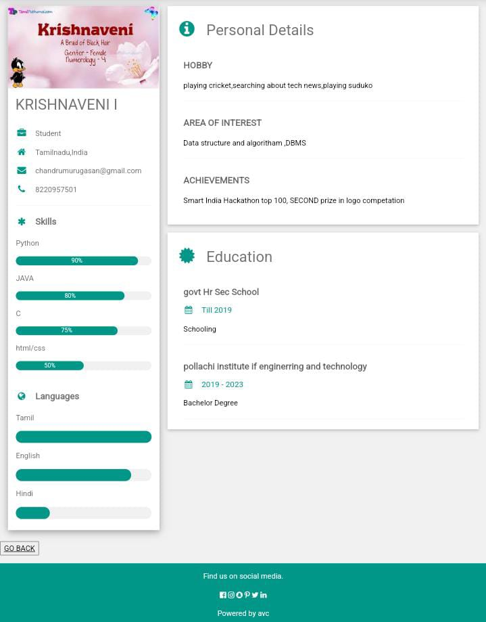**output:**